Daily Stand-Up Meeting
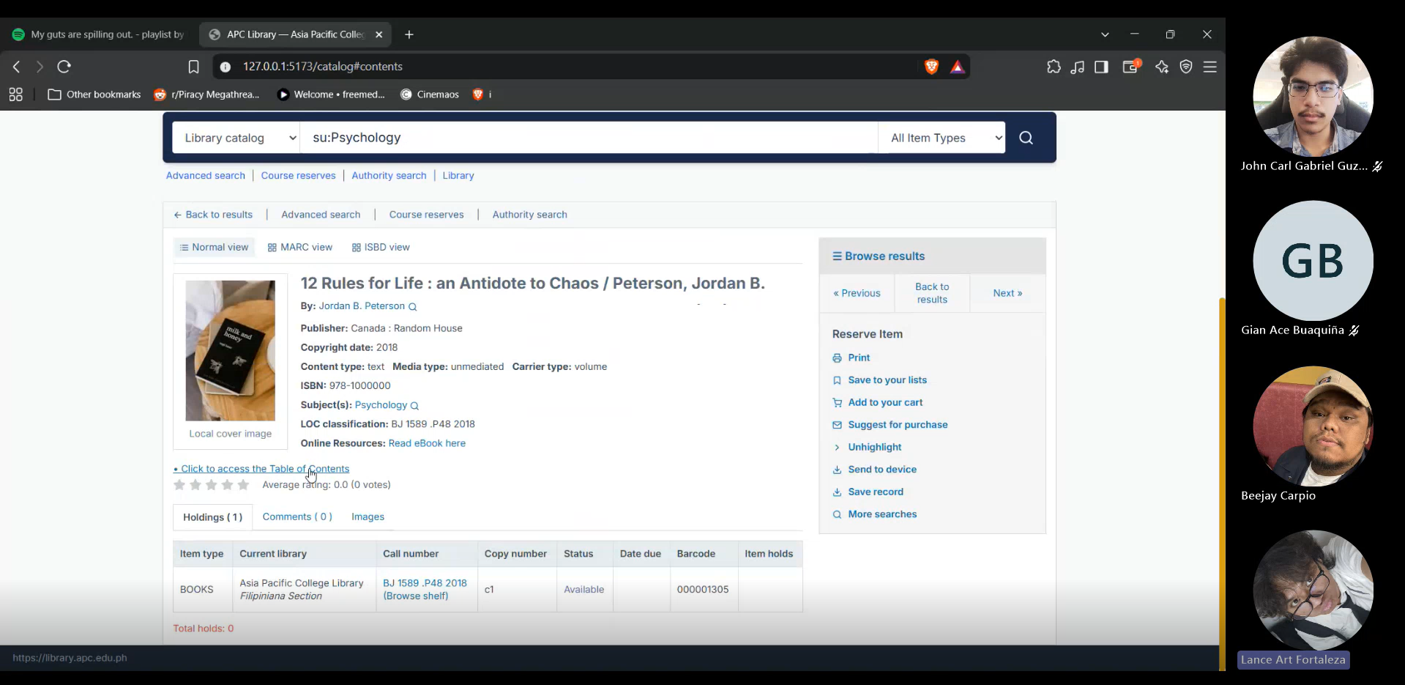
Minutes of Meeting
Date: 09/23/2026
Meeting Called By: Cache Flow
Meeting Link: Daily Stand-Up Meeting-20260923_205812-Meeting Recording.mp4

Attendees
Gian Ace Buaquiña
Beejay A. Carpio
Lance Art P. Fortaleza
John Carl Gabriel Guzman

Summary
Discuss progress on repository migration, Koha backend configuration, UI enhancements, and upcoming consultations. Gian resolved the Koha credentials issue and successfully enabled the REST API for database testing. Lance created and set up the official dev branch on the repository provided by Sir Sean, migrating the frontend files, adding the Microsoft SSO login placeholder page, and updating the catalog UI layout. Beejay worked on the C4 Component Diagrams and Activity Diagrams for the librarian side while preparing the ERD draft. The team also planned for their weekly status report meeting with Sir Sean (Sir Eg), an on-site Saturday development session, and a future consultation with client Ms. April.

What we did yesterday
- Beejay A. Carpio: Drafted the Activity Diagram for the librarian/admin module and initiated work on the Entity-Relationship Diagram (ERD).
- Lance Art P. Fortaleza: Consulted with Sir Maynard at ITRO regarding Microsoft Entra ID (SSO) admin permissions for APC tenant authentication.
- Gian Ace Buaquiña: Consulted with Sir Maynard at ITRO regarding Koha server host RAM memory expansion to resolve system performance blockers.
- John Carl Gabriel Guzman: Did the Minutes of Meeting (MOM) for Day 6 and Day 7, and consulted on-site with Sir Jojo and Sir Maynard regarding team technical blockers.

What we did today
- Gian Ace Buaquiña: Resolved Koha system network credential issues, enabled the REST API, and explored backend connection workflows to communicate with the Koha API.
- Lance Art P. Fortaleza: Created and pushed frontend files to the dev branch on the official repository given by Sir Sean, added the Microsoft SSO login placeholder page, and structured book catalog category/detail views.
- Beejay A. Carpio: Drafted C4 Component Diagrams for both student and librarian modules, prepared the ERD draft, and scheduled consultations with Sir Sean.
- John Carl Gabriel Guzman: Did the Minutes of Meeting (MOM), assisted Beejay in gathering ERD attributes.

